Selenium RC Setup

Please follow these steps to setup selenium-rc <http://seleniumhq.org/docs/05_selenium_rc.html>

1. Install Selenium rc server with this [link](http://selenium.googlecode.com/files/selenium-server-standalone-2.25.0.jar)
2. Download and Install Eclipse for Java Edition.
3. Please follow the below steps to run the individual selenium server.

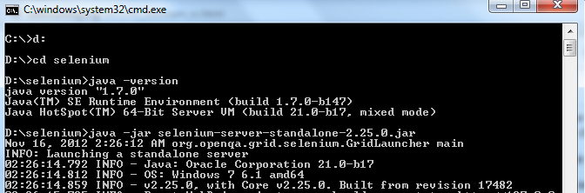

Wherever your selenium jar located, go to that directory.

Run the command java –jar selenium-server-standalone-2.25.0.jar

1. Now set up your eclipse with selenium rc.
2. Open Eclipse
3. Goto File > New and Select Others 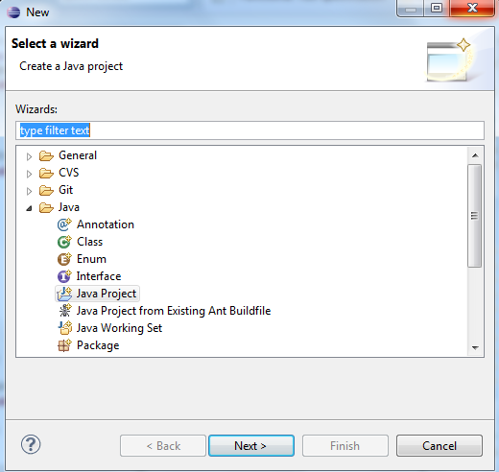
4. Select Java Project > Next 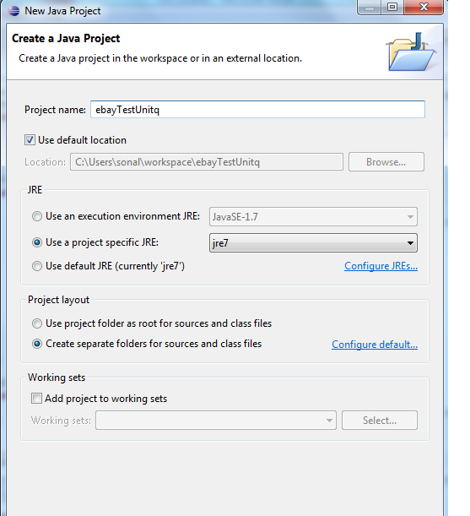
5. Again Next 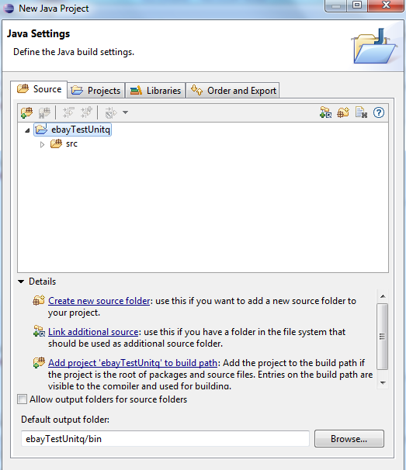
6. Finish
7. Create the project structure like following image 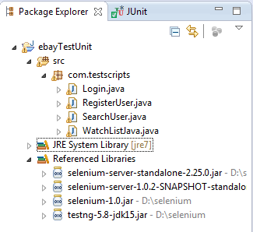
8. Include all necessary jar for selenium rc please download following jars from internet 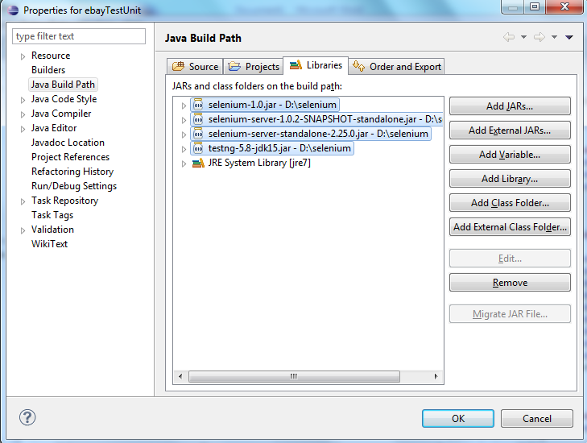
9. So these jars automatically included in project reference libraries
10. Login.java 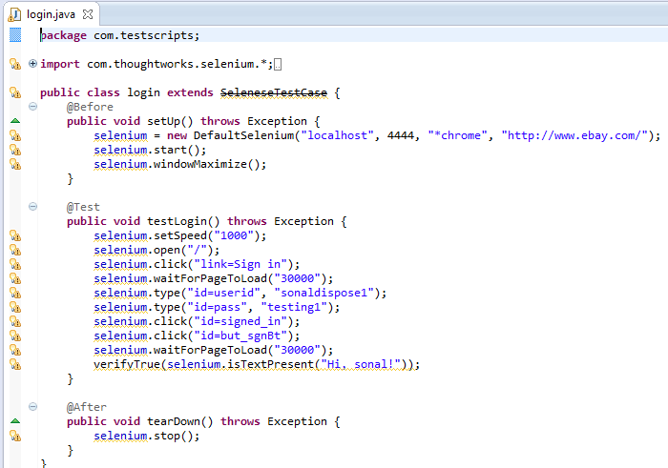
11. RegisterUser.java 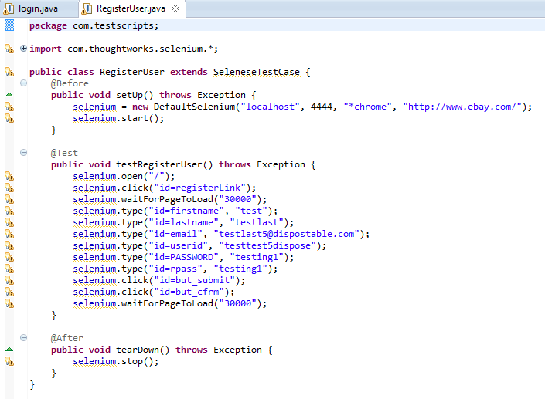
12. SearchUser.java 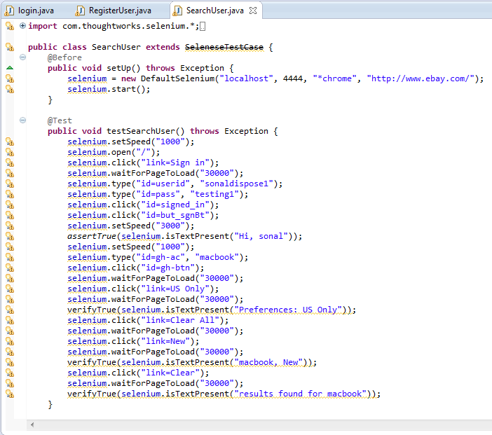
13. simplesearch.java 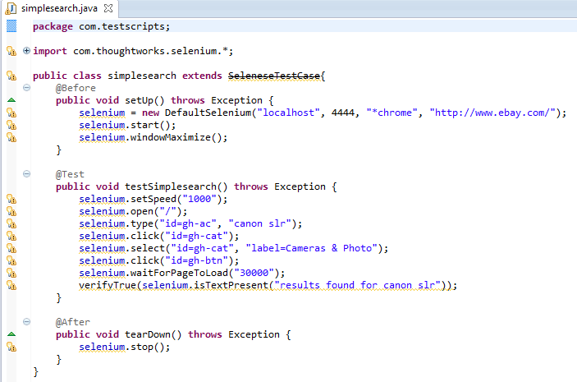
14. tooseewatchlist.java 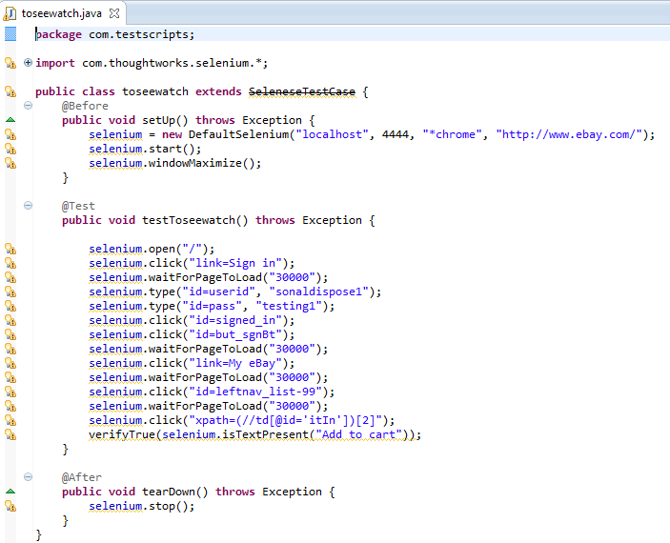
15. WatchList.java 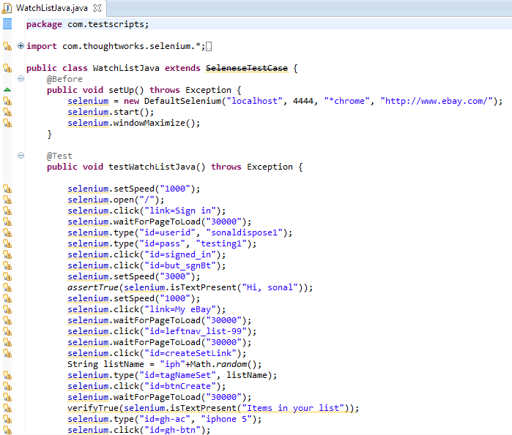
16. Now Run the individual Test case using right click on the file and then run as Jnuit 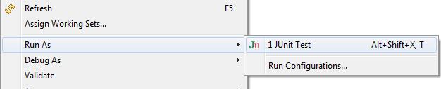
17. Register User with Selenium RC 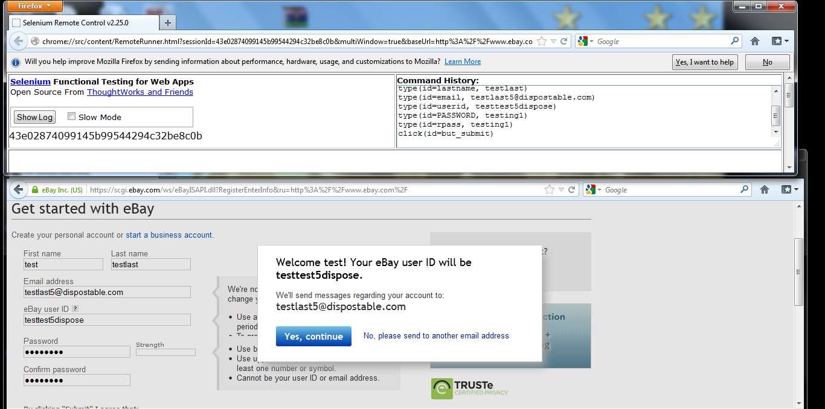
18. All Source files are in src\com\testscripts folder.